[](http://www.chelmsfordssp.com/)  
  
**Star of the Week**

**Harry Kane**

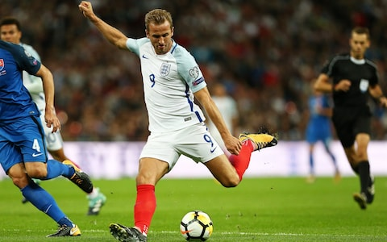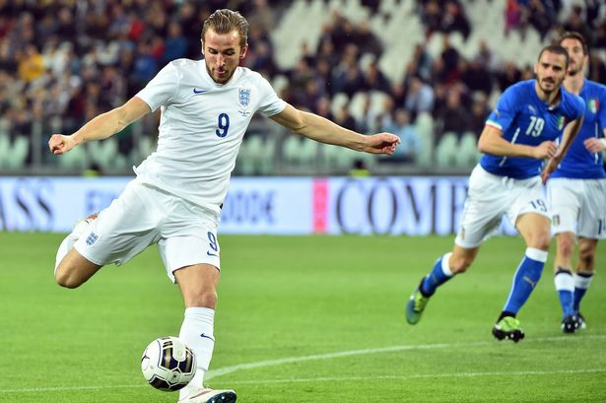

**Harry Edward Kane** [MBE](https://en.wikipedia.org/wiki/Order_of_the_British_Empire) (born 28 July 1993) is an English professional [footballer](https://en.wikipedia.org/wiki/Association_football) who plays as a [striker](https://en.wikipedia.org/wiki/Striker_(association_football)) for [Premier League](https://en.wikipedia.org/wiki/Premier_League) club [Tottenham Hotspur](https://en.wikipedia.org/wiki/Tottenham_Hotspur_F.C.) and [captains](https://en.wikipedia.org/wiki/Captain_(association_football)) the [England national team](https://en.wikipedia.org/wiki/England_national_football_team). Born and raised in the London district of [Walthamstow](https://en.wikipedia.org/wiki/Walthamstow), Kane began his professional career at Tottenham Hotspur, where, after fast progression through the team's youth academy, he was promoted to the senior team in 2009, at age 16. He did not initially feature for the side, and was [loaned](https://en.wikipedia.org/wiki/Loan_(sports)) out several times to clubs across the [English football pyramid](https://en.wikipedia.org/wiki/English_football_league_system), including [Leyton Orient](https://en.wikipedia.org/wiki/Leyton_Orient_F.C.), [Millwall](https://en.wikipedia.org/wiki/Millwall_F.C.), [Leicester City](https://en.wikipedia.org/wiki/Leicester_City_F.C.), and [Norwich City](https://en.wikipedia.org/wiki/Norwich_City_F.C.).

**Games Challenge**

**What sport am I ?**

Player one acts out a sport without speaking and without equipment. The other players have to guess the sport. If a player guesses correctly then the player who acted it out gets a point. The person who guessed correctly also gets a point and it is their go next. How many different sports can your family or school bubble think of?

Differentiation:

**S**pace - try playing it standing up, moving around

**T**ask – try playing it by “speaking “no moving and describing the sport, without saying the name of the sport. Play again by acting out characters from different themes: Disney films or characters from Story Books (Harry Potter) or SuperHeroes? **E**quipment – use markers to stay 2m apart if you are at school.

**P**eople – play in pairs or with all the family or with your school bubble.

**Orienteering Challenge,**

**On the move challenge.**

When playing this game you must be moving all the time (no standing still). When you are outside on a walk, in the garden or on the school field or school playground, walk about and see how many different colours you can find?

If you find 4- 6 colours you are a bronze champion, 7- 9 colours Silver champion 10 – 12 Gold champion and 13 or more Platinum Champion .

Set another I spy challenge for your friends or family and as you play try skipping or running, (not walking)? You could choose different themes, shapes , natural things, different materials, types of cars, types of trees, names of streets or something else you decide?

Creative Activity

Troll Dance Challenge

The new Trolls Movie is now out and we have a Dance teacher who has created a dance for you to learn, using the Trolls Music. Click on this link or go to our website Chelmsfordssp.com and click on physical challenges – you will find Video 16 Troll Dance lesson for you to learn.

You can do this at home or in school in your school bubble.

**Fitness Challenge**

Below are some ideas to help keep you active each day this week. Whether at school or home, see if you can do them?

**Skill Challenge**

Look at the **'Keep Essex Active'** YouTube channel.

There are a wide variety of exercise sessions for the whole family.

Can you challenge yourself to complete one today?



MONDAY

Can you walk, run, scoot or cycle for 30-60 minutes?

Walking is such an easy way to get our 60 minutes a day!

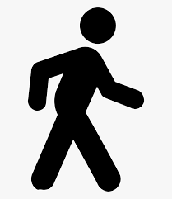

tuesday

How many of each exercise can you complete in 30 seconds?

**Star Jumps**

**Squats**

**Lunges**

**Burpees**

**Press Ups**

**Sit Ups**

Challenge a family member to a competition.

Think of a reward for the winner!

WEDNESDAY

Can you practise some skills from your favourite sport? You may not have all the equipment but what can you find from around the house that will work?

Look up some online tutorials to help you.



THURSDAY

Complete a Joe Wicks workout on the Body Coach YouTube Channel.

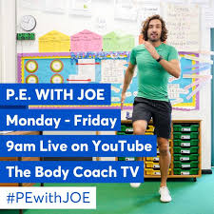

FRIDAY

Download the TopYa! App and complete a challenge. Compete against other students and represent your school.



<https://www.yourschoolgames.com/coronavirus-support/school-games-active-championships/>

SATURDAY

Create your own game and think about what the rules are going to be

**Or**

Create a physical skills course indoors or outside for your household or school bubble to complete.

Share your ideas on twitter @chelmsfordSsp

sunday

**Jump the Cross**

**Balance is really important in all sports, all you need to try this challenge is two lines on the floor making a cross shape. To make your cross you could use chalk lines, throw down lines, ropes or if at home maybe rolled up tea towels.**

C

D

B

A

**Challenges**

|  |  |
| --- | --- |
| **Challenge 1** | **Starting in area ‘A’ travel around the cross using two footed bunny hops. B-C-D-A and then back around the other way D-C-B-A. See how many you can complete in 30 seconds.** |
| **Challenge 2** | **Following the same pattern as above now complete the challenge hopping on one foot only. Remember always try the other foot as well.** |
| **Challenge 3** | **Diagonal travel. Starting in area ‘A’ travel around the cross using two footed bunny hops. C-D-B-A and then back around the other way D-C-A-B. See how many you can complete in 30 seconds.** |
| **Challenge 4** | **Following the same pattern as above now complete the challenge hopping on one foot only. Remember always try the other foot as well.** |
| **Challenge 5** | **Have a partner call out an order to travel around the cross and see how many instructions you can follow before making a mistake.** |
| **Challenge 6** | **Mirror Mirror – With a partner keeping at least 2m distance between you decide who is the leader and who is going to follow. Start in the same boxes as each other, when the leader moves the follower must move into the correct box see how many you can copy without making a mistake.** |
| **Challenge 7** | **Pattern- Your partner can call out an order of 4 instructions to copy. If you complete the pattern you get a point. You can increase the challenge by adding more instructions to remember.** |

Differentiation:

**S**pace – Change the distance you travel across the cross on the floor.

**T**ask – Look at the challenges above

Equipment – Rather than flat lines on the floor you can increase the difficulty by making them raised, use cones or jumpers to mark out the cross.

**P**eople – you can play as an individual or use a partner to play the harder game

**Don’t forget to use the Legacy Chart to record the values you have shown this week. Write the date beside the values.**

**Good Luck everyone.**