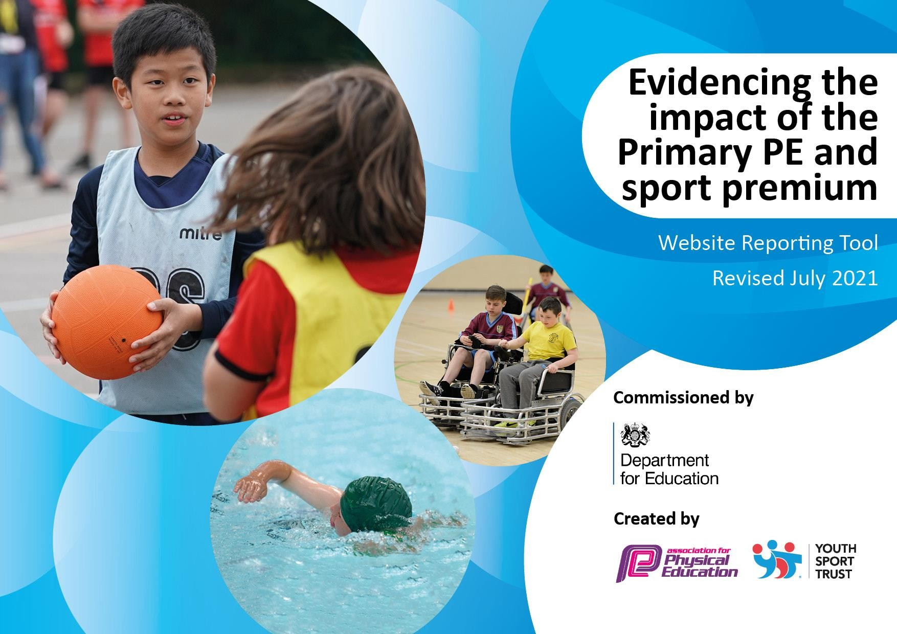

BARNES FARM JUNIOR SCHOOL 2021-22 REVIEW

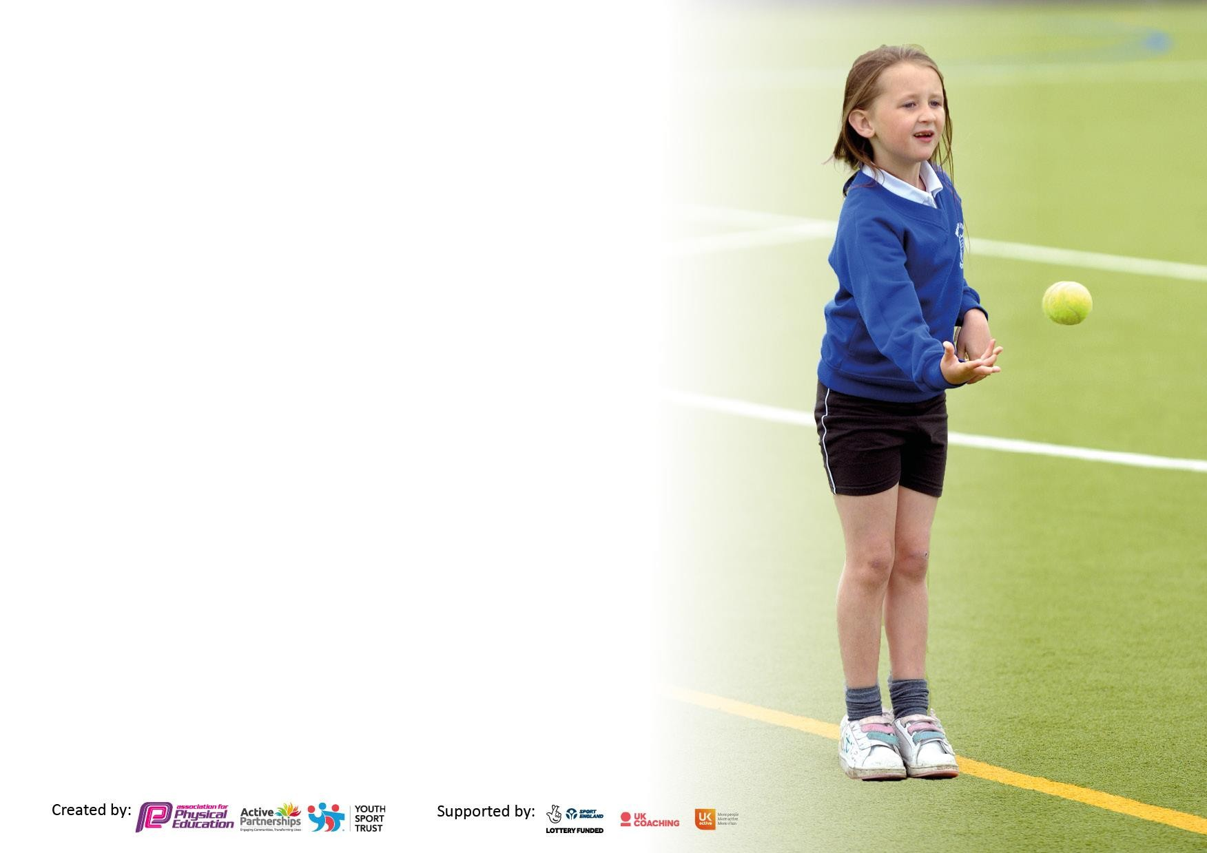
It is important that your grant is used effectively and based on school need. The Education Inspection Framework makes clear there will be a focus on ‘whether leaders and those responsible for governors all understand their respective roles and perform these in a way that enhances the effectiveness of the school’.

Under the Quality of Education Ofsted inspectors consider:
Intent - Curriculum design, coverage and appropriateness
Implementation - Curriculum delivery, Teaching (pedagogy) and Assessment
Impact - Attainment and progress

To assist schools with common transferable language this template has been developed to utilise the same three headings which should make your plans easily transferable between working documents.

Schools must use the funding to make additional and sustainable improvementsto the quality of Physical Education, School Sport and Physical Activity (PESSPA) they offer. This means that you should use the Primary PE and sport premium to:

- Develop or add to the PESSPA activities that your school already offer
- Build capacity and capability within the school to ensure that improvements made now will benefit pupils joining the school in future years
- The Primary PE and sport premium should not be used to fund capital spend projects; the school’s budget should fund these.

Please visit gov.uk for the revised DfE guidance including the 5 key indicators across which schools should demonstrate an improvement. This document will help you to review your provision and to report your spend. The DfE encourages schools tousethistemplateasaneffectiveway of meeting the reporting requirements of the Primary PEandsport premium.

We recommend you start by reflecting on the impact of current provision and reviewing the previous spend.

Schools are required to publish details of how they spend this funding, including any under-spend from 2019/2020, as well as on the impact it has on pupils’ PE and sport participation and attainment. All funding must be spent by 31st July 2022.

We recommend regularly updating the table and publishing it on your website throughout the year. This evidences your ongoing self-evaluation of how you are using the funding to secure maximum, sustainable impact. Final copy must be posted on your website by the end of the academic year and no later than the 31st July 2021. To see an example of how to complete the table please click HERE.

Details with regard to funding
Please complete the table below.

Total amount carried over from 2019/20
Total amount allocated for 2020/21
How much (if any) do you intend to carry over from this total fund into 2021/22? | £0
Total amount allocated for 2021/22 | £21,507
Total amount of funding for 2021/22. To be spent and reported on by 31st July 2022. | £21,507
Swimming Data
Please report on your Swimming Data below.

Meeting national curriculum requirements for swimming and water safety.  N.B. Complete this section to your best ability. For example, you might have practised safe self-rescue techniques on dry land which you can then transfer to the pool when school swimming restarts.  Due to exceptional circumstances priority should be given to ensuring that pupils can perform safe self-rescue even  if they do not fully meet the first two requirements of the NC programme of study | Due to Covid restrictions over the last two academic years – this cohort has missed out on their full swimming allocation and therefore no reliable data is available.
What percentage of your current Year 6 cohort swim competently, confidently and proficiently over a distance of at least 25 metres? N.B. Even though your pupils may swim in another year please report on their attainment on leaving primary schoolat the end of the summer term 2020.  Please see note above | Data to be collected
What percentage of your current Year 6 cohort use a range of strokes effectively [for example, front crawl, backstroke and breaststroke]?  Please see note above | Data to be collected
What percentage of your current Year 6 cohort perform safe self-rescue in different water-based situations? | Data to be collected
Schools can choose to use the Primary PE and sport premium to provide additional provision for swimming but this must be for activity over and above the national curriculum requirements. Have you used it in this way? | No - due to Covid 19 we did not  arrange extra lessons for children in the summer term.

Action Plan and Budget Tracking
Capture your intended annual spend against the 5 key indicators. Clarify the success criteria and
evidence of impact that you intend to measure to evaluate for pupils today and for the future.

Sports Funding
Key Indicator 1 - Increased physical activity

Key Indicator 2 - Raise the profile of school sport Key Indicator 3 - Staff skills and knowledge of PE Key Indicator 4 - Increased range of sports offered Key Indicator 5 - Competitive sport at school

Provision / Initiative | Budget allocated /  % of annual budget | Key Indicator covered | Intent | Implementation | Impact
Equipment/training purchase | £1000 | 1,3,4,5 | Equipment to be used by all pupils during lunchtime activities.  Break/lunchtimes are more active and productive.  More children to achieve their 60 Active minutes  Wider range of sports to be offered, such as yoga/mindfulness club and table-tennis club | Ordering new sporting equipment that can be used at lunchtimes to encourage physical activity  Recruitment of Playleaders/Health Ambassadors in school to encourage physical activity at lunchtimes  PE Curriculum Day to introduce new sports and activities for active breaks and wet play activities. in class such as cardio-drumming | New table-tennis club has been set up. This has been over-subscribed.  More pupils are able to be active at lunchtimes.  Skipping is used as an active break by most classes throughout the day. Skipping ropes have been added to the pupils personal PE equipment bags.  These are recycled back to year 3 at the end of year.  PE lessons are all fully resourced and equipment if a a safe and high standard.
Chelmer Road Runners  Chelmsford Hockey Club  Chelmsford Sports and athletics club | £800 | 1,2,3,4 | Children are educated about the benefits and techniques for running safely.  The Daily Mile track is utilised fully.  Children feel more confident to have a go at running.  Use positive role models to encourage participation.  Teachers are upskilled to advise/support runners during daily mile.  Raise profile of physical activity. | Running workshops with Chelmer Road Runners for year 3 and 4 during the Autumn term.  Teachers to work alongside coaches.  Chelmsford Hockey Club and CSSP provided coaching sessions for free in conjunction with our membership to CSSP. | Daily Mile track is used by all classes. Pupils are more willing to ‘have a go’ when running and use techniques taught.  Children felt involved and connected to the upcoming Commonwealth Games and their questions/contributions were valued.  Impact to be assessed in September with collation of CWG survey responses (visit took place on 12th July.)  Teachers in year 6 were upskilled through team teaching with Hugh Fillingham.
Membership to Sports Partnership | £1444 | 1,2,3,4,5 | To access high quality support and PE provision.  For children to be able to attend the huge variety and quantity of events for year groups and for sports teams.  To offer all school staff CPD in PE / Sport / Lunchtime activities. To keep up to date with current initiatives and advice. | Events for teams and classes are organised and attended.  Access to CPD.  PE lead attended termly meetings.  Yoga training provided for teacher and a club is now running.  New initiatives are shared with the school via Primary Link Teacher.  Links with outside agencies shared via Newsletters and leaflets sent home.  All staff have access to the CSSP website and virtual/visual resources including rules for competition. | Children attended a variety of events and enjoyed participating in individual or team events.  Staff accessed CPD and worked with  primary colleagues in PE.  Yoga club is well attended.  Many children were able to represent the school and take part in competition.  A wider range of staff have been able to attend competitions and become upskilled in a range of sports.  The school reached 3 Level 3 competitions.
SCS Sports Coaches X3 | £15,000 | 1,2,3,4,5 | To support active play times  To offer a range of and regular access to lunchtime sessions that promote physical activity,  allowing children to work in teams, practice skills and socialise. | Coaches organise activities / games at lunch time to encourage children to be  physically active.  Use of 3 coaches enables more activities and a wider range to take place.  Zoned areas for different activities and a timetable for the week, rotating sports. | Children active at lunchtimes - supports their physical and mental  development.

 |  |  | To offer extra-curricular sport to children who may not attend otherwise. | Equipment previously purchased will now be used in rotation.  Zone areas on the field/MUGA and playground. | . Children access competitive sport / training for the first time. Offers route to clubs  outside of school. Less children are needing support from MDAs for behaviour issues at lunchtimes. Play times are more productive and more pupils are achieving their 6o Active minutes.  Equipment such as table tennis tables that have been purchased through previous years funding are now being utilized before/during and after school.
Transportation to events and competitions | £1343 | 1,4,5 | To give children regular opportunities to attend inter-school sporting events or other sporting-based events. | To increase the participation in Level 2 and 3 sport. To ensure that the competitions are spread across the year groups and abilities.  Some competitions to still run virtually – fitness 3’s.  Report sporting achievements in newsletters, parents evening, school reports and celebrate in assembly. | The school has provided a full calendar of inter-school competition to include a wider representation of events this year including tennis.  Particular competitions were aimed at pupils that don’t usually represent the school and therefore – a wider range of pupils are being represented.
Raise profile of PE and Sport | £300 | 1,2,3,4 | Continue with intra-house competitions.  Organise a PE Curriculum Day.  Introduce more positive role models from the world of sport and fitness.  Expose children to a wider range of activities. | Intra – house competitions held at lunchtime. Open to all pupils to represent their House in football or cricket.  Positive role models introduced in assemblies.  Sports Day split into year ¾ and 5/6  All staff/pupils involved.  PE curriculum day – Equipment loaned from CSSP. Timetable of activities for all year groups. Participation/rejuvenation of less familiar sports. – Tri-Golf, Box-fit, Archery, Kurling, Boccia, cardio-drumming and speed stacking.  Visit from 2 X commonwealth athletes (who train locally.) All pupils to take part in Q and A. Selected pupils to take part in workshop with athlete.  Certificates awarded termly by SCS Sports Coaches  Pupils selected to attend a gifted/talented workshop at Boswells School  Sporting achievements reported in weekly newsletters, celebration assembly and staff notice board in | Cardio-Drumming filtering into the class during the Summer term. This will be used  The children and staff had an extremely enjoyable day and were able to make the most of the opportunities provided. The profile and importance of Physical Education was raised and the children were able to experience different ways of being active.  Feedback from staff and children was excellent and
Project Dance and performance at Civic Theatre | £400 | 1,4,5 | For pupils to work alongside a choreographer to create, perform and stage a dance.  To perform in front of peers at school.  To perform for a theatre audience. | Rachel Squire from Project Dance to attend school to work with 30 year 5 pupils of mixed ability.  A contemporary dance to be choreographed by Rachel and the pupils. They will help to select the staging, moves and costumes.  2 sessions to take place with Rachel at school and a further session as a run-through at the Civic Theatre on the afternoon of the show.  Pupils to perform to their peers as a dress rehearsal and then in the evening at the theatre. | The dance was of excellent quality. The pupils devoted time to practice at break and lunch times and especially enjoyed sharing it with the school and their own parents. The dance was recorded on video for the children to keep.  The group performed at the Civic Theatre in front of their parents and a large audience. They also got to experience watching others dance performances. The group also performed twice in school to the lower and upper school pupils and staff.  The show was a huge success and the children enjoyed the experience from start to finish. Feedback from staff, pupils and parents was excellent.
Yoga training course  Supply cover | £320 | 1,3,4 | To broaden the range of clubs and to offer something low impact and mindful.  To upskill teachers in Yoga teaching.  Purchase of yoga mats | One teacher to attend training in yoga provided by CSSP. Supply cost needs to be covered for the teacher to be able to attend. | A successful yoga/mindfulness club began in the Summer term and will continue in the Autumn. Pupils in attendance were some of those that had not attended clubs in the previous term.
Memberships | £900 | 1,3,4 | To provide resources suitable for lesson planning.  Membership to organisations and online resources to enhance PE and active lessons. | Membership to Jump Start Jonny for 12 classes.  PE hub used for long/medium term planning tool and for support with lesson planning and skills videos.  PE Hub membership for one year  Imoves Dance/yoga/mindfulness/active breaks. This includes use of music for planning dance lessons and is linked to curriculum topics. | Resources used for enhancing PE lessons and for teachers planning structured clubs.  Teachers report that they have useful resources enjoyed by the children and they are linked to curriculum subjects as well as PE and PHSE.

Plans for 2022-23 (subject to change)

Provision / Initiative | Planned costs | Key Indicator covered | Intent
Develop a further area of the playground/field for activity | £3,000 | 1&5 | Due to recent building work in the school grounds, a further area is available with the potential to develop into an active zone. The exact details of the area will not be known until September when
Supplement Club costs | £ 1000 | 1,4, 5 | Investigate ways to pay a supplement for clubs in or out of school for pupils who would not usually be able to attend.
Transport to events | £200 | 1&5 | Increase number of sporting events that the school is able to attend.
Admin time | £1149 | 1,2,3,4,5 | To ensure forms / letters / registers and other organisational tasks are completed for  events to take place.
Chelmsford School Partnership | £1,444 | 1,2,3,4,5 | Continue with membership in order to attend competition and CPD.
Swimming top up | £ 3000 | 1,4,5 | Arrange top up sessions at the end of the school year or beginning of Academic year 2024 once curriculum swimming has taken place.

