How to log in to your Microsoft Office 365 account (pupils)

1. Go to https://id.sims.co.uk/ or search for sims id in your search engine.

2. Enter the pupil’s email address as the Username and enter the Password (the 3-character password specific to the pupil). Click ‘Sign in’.

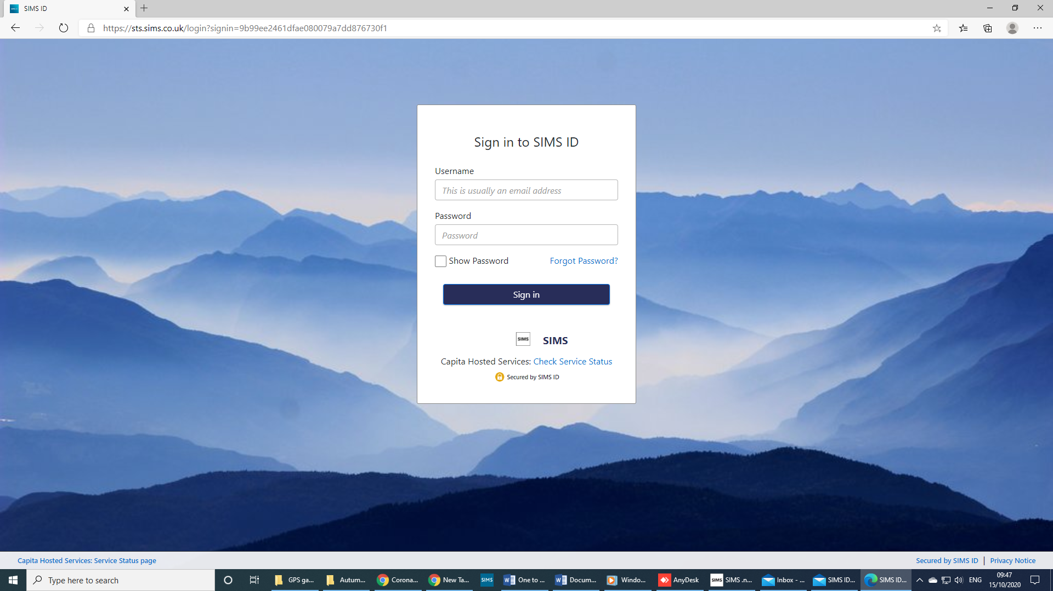

3. Click on the red box – ‘Office 365 portal’

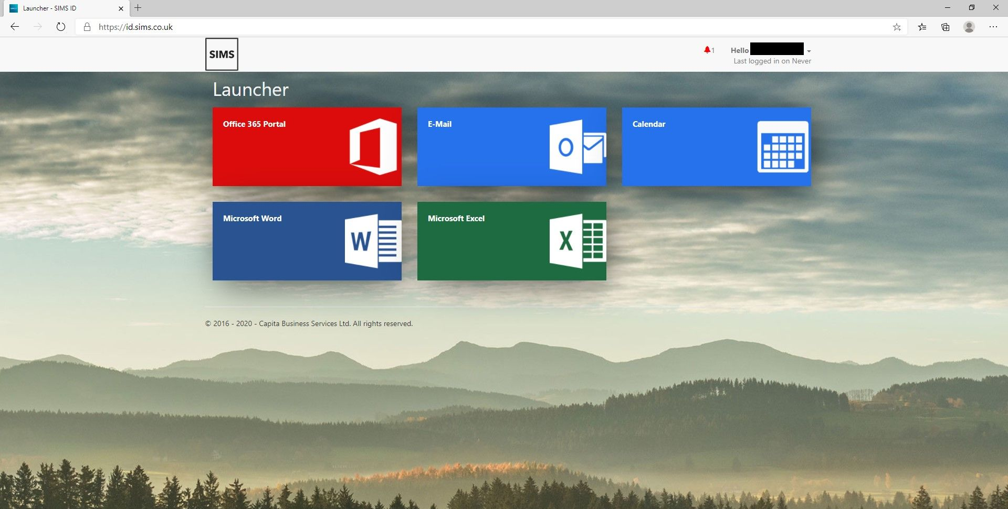

4. You will be taken to your personal Office 365 suite of applications as shown below. From here, you can access and use programs such as Word, PowerPoint, Outlook (email), SharePoint and Teams.

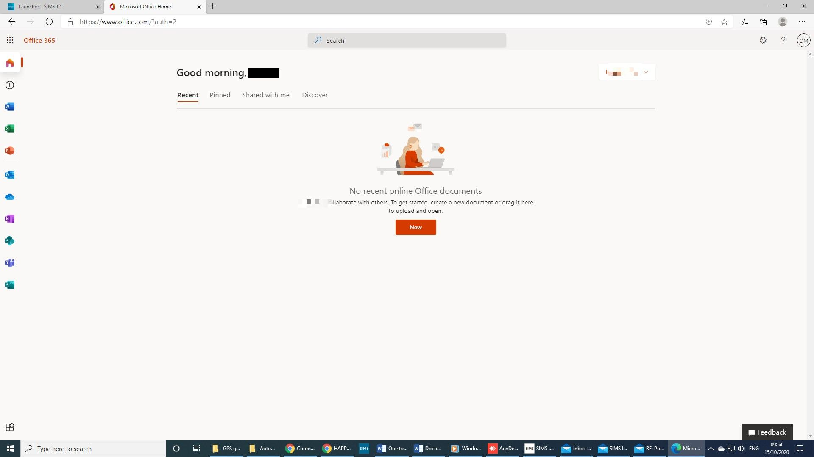

How to access online learning

1. Click on the Teams application to begin to access online learning.

2. You are likely to presented with the next screen (unless you have already used Teams on your device and have already selected one of the options). You can choose to either download the Teams Windows app or simply continue using the web app (i.e. continue using the internet browser you are on).

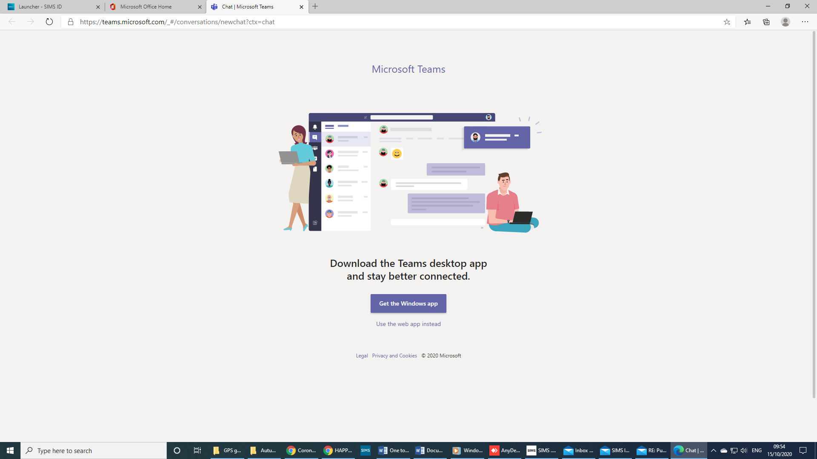

7. You will then be taken into the Teams app.

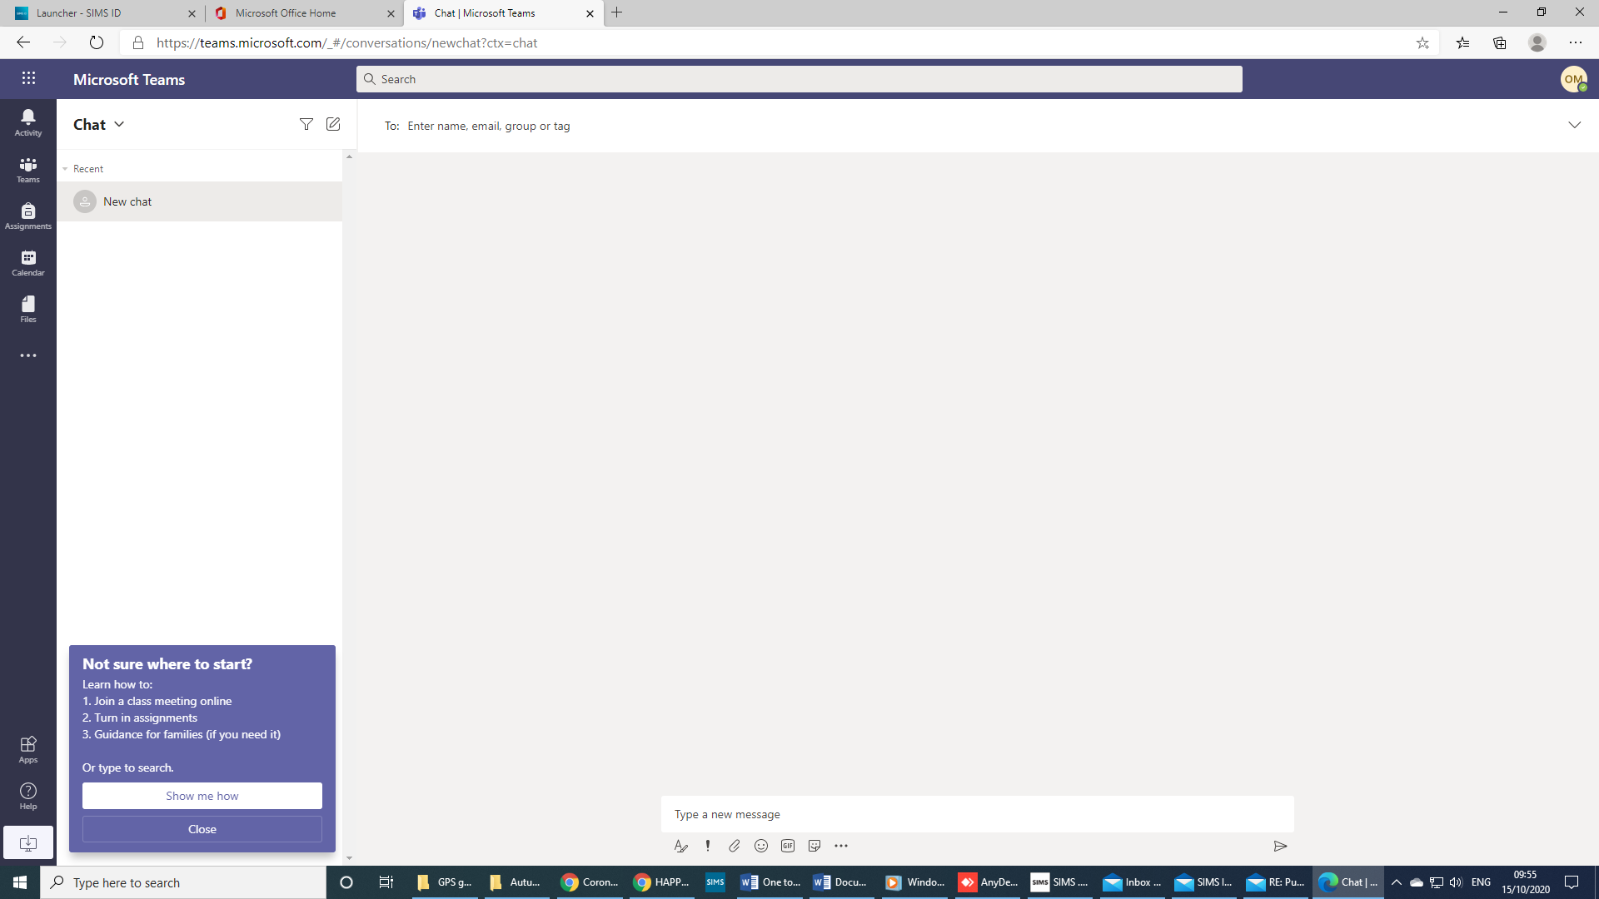

You can then join online learning either by clicking on ‘Teams’ and selecting your class or by using the ‘Calendar’ if you have been sent a meeting invitation.

